A

Mini Project On

#### DIGITAL ADDRESS CODE

(Submitted in partial fulfillment of the requirements for the award of Degree)

BACHELOR OF TECHNOLOGY

In

COMPUTER SCIENCE AND ENGINEERING

By

SHAIK DANISH(197R1A05P6)

Under the Guidance of

**A.UDAY KIRAN**

(Assistant Professor)

##### DEPARTMENT OF COMPUTER SCIENCE AND ENGINEERING

**CMR TECHNICAL CAMPUS UGC AUTONOMOUS**

(Accredited by NAAC, NBA, Permanently Affiliated to JNTUH, Approved by AICTE, New Delhi) Recognized Under Section 2(f) & 12(B) of the UGCAct.1956, Kandlakoya (V), Medchal Road, Hyderabad-501401.

**2019-2023**

**DEPARTMENT OF COMPUTER SCIENCE AND ENGINEERING**



#### CERTIFICATE

This is to certify that the project entitled **“DIGITAL ADDRESS CODE”** being submitted by SHAIK DANISH**(197R1A05P6)**in partial fulfillment of the requirements for the award of the degree of B.Tech in Computer Science and Engineering to the Jawaharlal Nehru Technological University Hyderabad, is a record of bonafide work carried out by them under our guidance and supervision during the year 2022-23.

The results embodied in this thesis have not been submitted to any other University or Institute for the award of any degree or diploma.

**A. UDAY KIRAN Dr. A. Raji Reddy**

(Assistant Professor) DIRECTOR

INTERNAL GUIDE

**Dr. K. Srujan Raju EXTERNAL EXAMINER**

HOD

**Submitted for viva voice Examination held on**

##### ACKNOWLEDGEMENT

Apart from the efforts of us, the success of any project depends largelyonthe encouragement and guidelines of many others. We take this opportunity to express our gratitude to the people who have been instrumental in the successful completion of this project.

We take this opportunity to express my profound gratitude and deep regard to my guide **A UDAY KIRAN,** Associate Professor for his exemplary guidance, monitoring and constant encouragement throughout the project work. The blessing, help and guidance given by him shall carry us a long way in the journey of life on which we are about to embark.

We also take this opportunity to express a deep sense of gratitude to the Project Review Committee (PRC) **Dr. Punyaban Patel, Ms. Shilpa, Dr.T . Subha Mastan Rao & J. Narasimharao** for their cordial support, valuable information and guidance, which helped us in completing this task through various stages.

We are also thankful to **Dr. K. Srujan Raju,** Head, Department of Computer Science and Engineering for providing encouragement and support for completing this project successfully.

We are obliged to **Dr. A. Raji Reddy,** Director for being cooperative throughout the course of this project. We also express our sincere gratitude to Sri. **Ch. Gopal Reddy,** Chairman for providing excellent infrastructure and a nice atmosphere throughout the course of this project.

The guidance and support received from all the members of **CMR Technical Campus** who contributed to the completion of the project. We are grateful for their constant support and help.

Finally, we would like to take this opportunity to thank our family for their constant encouragement, without which this assignment would not be completed. We sincerely acknowledge and thank all those who gave support directly and indirectly in the completion of this project.

###### SHAIK DANISH(197R1A05P6)

##### ABSTRACT

Digital address code is an unique code assigned to each unique address that needs to be traced .This code is linked to latitude ,longitude and elevation for the accuracy .Digital address code is 12 digit code that includes accurate directions to an address .Digital address code would contain zone, state, district, area and unique code appended at the end. Digital address code decreases dependency on language as it is numeric .Digital address code improves time to reach an address.

|  |  |  |
| --- | --- | --- |
| **FIGURE NO** | **FIGURE NAME** | **PAGE NO** |
| Figure 3.1 | Project Architecture for DIGITAL ADDRESS CODE | 7 |
| Figure 3.2 | Use Case Diagram for DIGITAL ADDRESS CODE | 8 |
| Figure 3.3 | Class Diagram for DIGITAL ADDRESS CODE | 9 |
| Figure 3.4 | Sequence diagram for DIGITAL ADDRESS CODE | 10 |
| Figure 3.5 | Activity diagram for DIGITAL ADDRESS CODE | 11 |

|  |  |  |
| --- | --- | --- |
| **SCREESHOT NO.** | **SCREENSHOT NAME** | **PAGE NO**. |
| Screenshot 5.1 | Login page | 16 |
| Screenshot 5.2 | Sign page | 17 |
| Screenshot 5.3 | Creation of digital address code | 18 |
| Screenshot 5.4 | Tracing of digital address code | 19 |
| Screenshot 5.5 | Google map for given digital address code | 20 |

###### TABLE OF CONTENTS

###### ABSTRACT i

LIST OF FIGURES ii

LIST OF SCREENSHOTS iii

1. INTRODUCTION 1
   1. PROJECT SCOPE 1
   2. PROJECT PURPOSE 1
   3. PROJECT FEATURES 1
2. SYSTEM ANALYSIS 2
   1. PROBLEM DEFINITION 2
   2. EXISTING SYSTEM 2
      1. LIMITATIONS OF THE EXISTING SYSTEM 3
   3. PROPOSED SYSTEM 3
      1. ADVANTAGES OF PROPOSED SYSTEM 3
   4. FEASIBILITY STUDY 4
      1. ECONOMIC FEASIBILITY 4
      2. TECHNICAL FEASIBILITY 5
      3. SOCIAL FEASIBILITY 5
   5. HARDWARE & SOFTWARE REQUIREMENTS 5
      1. HARDWARE REQUIREMENTS 5
      2. SOFTWARE REQUIREMENTS 6
3. ARCHITECTURE 7
   1. PROJECT ARCHITECTURE 7
   2. DESCRIPTION 7
   3. USE CASE DIAGRAM 8
   4. CLASS DIAGRAM 9
   5. SEQUENCE DIAGRAM 10
   6. ACTIVITY DIAGRAM 11
4. IMPLEMENTATION 12
   1. SAMPLE CODE 12
5. RESULTS 16
6. TESTING 21
   1. INTRODUCTION OF TESTING 21
   2. TYPES OF TESTING 21
      1. UNIT TESTING 19
      2. INTEGRATION TESTING 20
      3. FUNCTIONAL TESTING 20
   3. TEST CASES 21
      1. CLASSIFICATION 21

###### CONCLUSION & FUTURE SCOPE 22

* 1. PROJECT CONCLUSION 22
  2. FUTURE SCOPE 22

###### REFERENCES

* 1. Bibliography 41
  2. Github link 41

# INTRODUCTION

#### INTRODUCTION

##### PROJECT SCOPE

This project is titled “digital address code”. Traditional methods based on shallow learning have been facing challenges like searching address, finding for exact location and change in the given address. Shallow learning based methods only utilize some basic features of given address and depend on artificial experience to extract sample features.

##### PROJECT PURPOSE

We use our Aadhar card as our address proof, but our address recorded on our Aadhar card cannot be digitally authenticated If seen, this is the shortcoming in each of our documents, to overcome this, in order to digitally authenticate any address, that address must be linked to a digital location (Geospatial Coordinates or Geospatial Coordinates). By doing this, the digital address identity will be able to use the address for online authentication.

##### PROJECT FEATURES

An exclusive and unique digital code for every address With the help of this app, you get an exclusive & customized short code for your long & complex address like KUMAR100 or SINGH221. 2. Accurate & precise address: You can select a 3*3-meter block on the digitai code

and mark the exact address location.

* 1. **SYSTEM ANALYSIS**

##### SYSTEM ANALYSIS

**SYSTEM ANALYSIS**

System Analysis is the important phase in the system development process. The System is studied to the minute details and analyzed. The system analyst plays an important role of an interrogator and dwells deep into the working of the present system. In analysis, a detailed study of these operations performed by the system and their relationships within and outside the system is done. A key question considered here is, “what must be done to solve the problem?” The system is viewed as a whole and the inputs to the system are identified. Once analysis is completed the analyst hasa firm understanding of what is to be done.

##### PROBLEM DEFINITION

Difficult to reach the exact address: If seen, the way online transactions have increased as well as online shopping has also increased to a great extent, but even today it is very difficult to reach an address for delivery.

##### EXISTING SYSTEM

Pin code is the only existing system to the digital address code in pin code we have some restrictions like while using the pin code we can only know the state, city, area and for the exact location we have to use the building name house number and other nearby resources to find out the exact location of the destination address and still in some cases we may get confused while reaching the address.

###### DISADVANTAGES OF EXISTING SYSTEM

Following are the disadvantages of existing system:

* Can get confused to get the exact location on time
* Can’t get the exact location by using pin code
* It is time a taking process

##### PROPOSED SYSTEM

For permanent identification and enabling easy tracing of each address ,we can use digital address code .It is a unique code assigned to each unique address that needs to be traced , this code is linked to latitude, longitude and elevation for the accuracy . It eliminates frauds in relation to addresses . To create a central database of addresses we can use digital address code . digital address code would only be issued to addresses which are liable to be traced, ensuring safety to hidden areas

##### FEASIBILITY STUDY

This project presents a system that recognizes people in video sequences using image information. More specifically we are interested in locating shots where some particular person appears in the image while talking, so that both face and voice are out of use. Examples of these shots include taped footage of news anchors, and head and shoulders sequences of people being interviewed. Moreover recording conditions for this type of shots are usually more controlled, making the recognition task more accurate.

* + - EconomicFeasibility
    - TechnicalFeasibility
    - SocialFeasibility

###### 2.41 ECONOMIC FEASIBILITY

The developing system must be justified by cost and benefit. Criteria to ensure that effort is concentrated on a project, which will give best, return at the earliest. One of the factors, which affect the development of a new system, is the cost it would require.

The following are some of the important financial questions asked during preliminary investigation:

* + - * The costs conduct a full system investigation.
      * The cost of the hardware and software.
      * The benefits in the form of reduced costs or fewer costly errors.

Since the system is developed as part of project work, there is no manual cost to spend for the proposed system. Also all the resources are already available, it give an indication that the system is economically possible for development

###### TECHNICAL FEASIBILITY

This study is carried out to check the technical feasibility, that is, the technical requirements of the system. Any system developed must not have a high demand on the available technical resources. The developed system must have a modest requirement, as only minimal or null changes are required for implementing this system.

###### BEHAVIORAL FEASIBILITY

This includes the following questions:

* + - * Is there sufficient support for the users?
      * Will the proposed system cause harm?

The project would be beneficial because it satisfies the objectives when developed and installed. All behavioral aspects are considered carefully and conclude that the project is behaviorally feasible

###### 2.5 HARDWARE & SOFTWARE REQUIREMENTS

###### HARDWARE REQUIREMENTS:

Hardware interfaces specify the logical characteristics of each interface between the software product and the hardware components of the system. The following are some hardware requirements.

* + - * Processor : Intel Dual Core I5 and above
      * Hard disk : 8GB and above
      * RAM : 8GB and above
      * Input devices : Keyboard, mouse

##### 2.5.2 SOFTWARE REQUIREMENTS:

Software Requirements specifies the logical characteristics of each interface and software components of the system. The following are some software requirements are:

* AZURE NO SQL & MYSQL Databases
* HTML/CSS & Java script or Websites
* Flutter/java or MIT app inventor for mobile app

## ARCHITECTURE

##### 3. ARCHITECTURE

##### PROJECT ARCHITECTURE

This project architecture shows the procedure followed for classification, starting from input to final prediction.

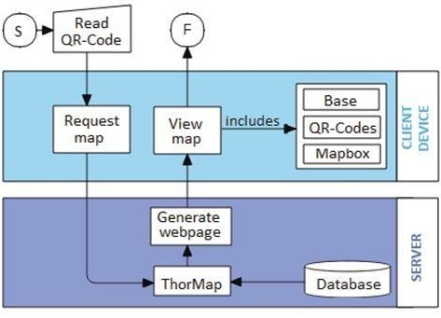

Figure 3.1: Project Architecture of digital address code

###### DESCRIPTION

This is project is totally based on creating and implementation of digital address code for the different address in the country with the help of their given features of the address and the code directly open the address in the map and navigate the user to the exact user address with out any third party interferance

###### USE CASE DIAGRAM

In the use case diagram, we have basically one actor who is the user in the trained model.

A use case diagram is a graphical depiction of a user's possible interactions with a system. A use case diagram shows various use cases and different types of users the system has. The use cases are represented by either circles or ellipses. The actors

are shown in the figure below.

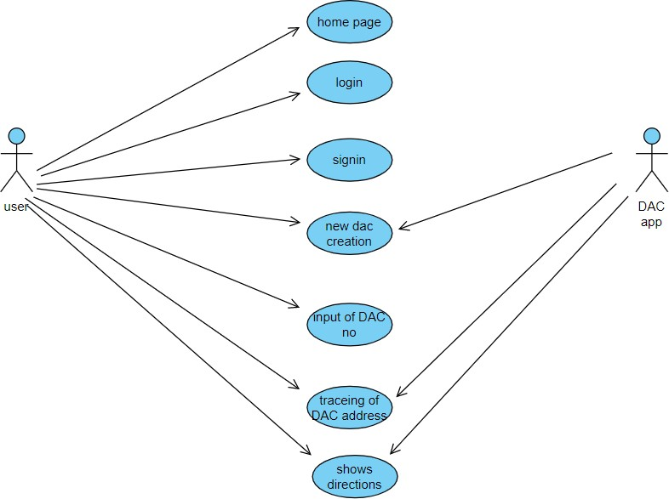

Figure 3.2: Use Case Diagram for Digital Address Code

##### CLASS DIAGRAM

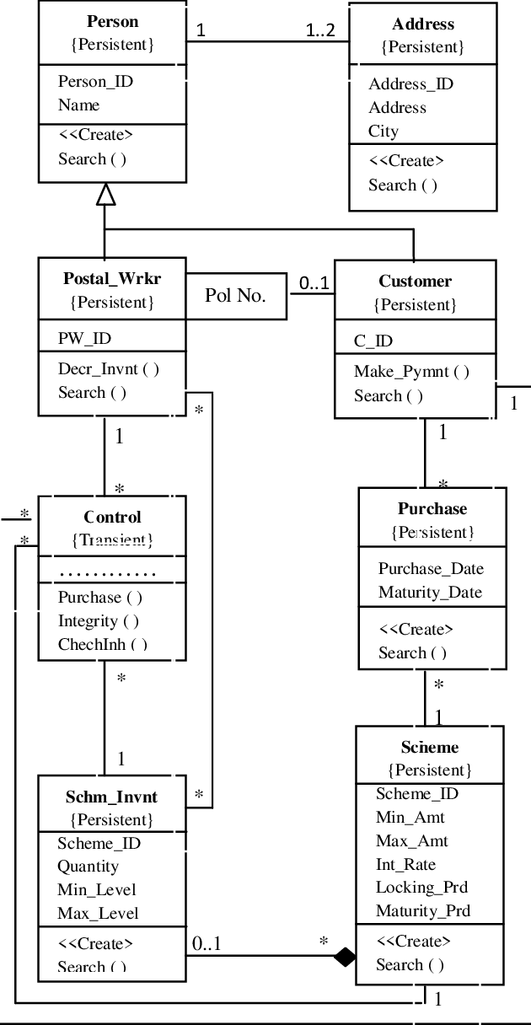Class diagram is a type of static structure diagram that describes the structure of a system by showing the system’s classes, their attributes, operations(or methods), and the relationships among objects.

Figure 3.3: Class Diagram for Digital address cod

##### SEQUENCE DIAGRAM

A sequence diagram shows object interactions arranged in time sequence.

It depicts the objects involved in the scenario and the sequence of messages exchanged between the objects needed to carry out the functionality of the scenario.

Sequence diagrams are typically associated with use case realizations in the logical

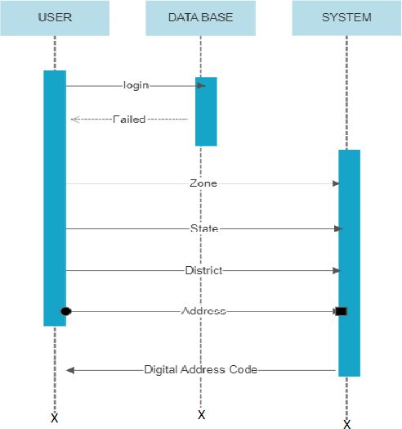

Figure 3.4: Sequence Diagram for DIGITAL ADDRESS CODE

* 1. **ACTIVITY DIAGRAM**

Activity diagrams are graphical representations of workflows of stepwise activities and actions with support for choice, iteration and concurrency. They can also include elements showing the flow of data between activities through one or more data stores.



Figure 3.5: Activity Diagram for Digital Address Code

21

# IMPLEMENTATION

**4.1 SAMPLE CODE**

import pandas as pd import numpy as np import cv2

import os import time

from utils import append_df_to_excel import pyttsx3

engine = pyttsx3.init() import datetime

video_capture = cv2.VideoCapture(0) # Initialize some variables known_face_encodings = [] known_face_roll_no = [] person_locations = [] address_encodings = [] person_names = [] process_this_frame = True attendance_record = set([]) roll_record = {}

# Rows in log file name_col = [] roll_no_col = [] time_col = []

df = pd.read_excel("student_db" + os.sep + "people_db.xlsx") student_face_encoding = face_recognition.face_encodings(student_image)[0] known_face_encodings.append(student_face_encoding) known_face_roll_no.append(roll_no)

for key, row in df.iterrows():

roll_no = row['roll_no'] name = row['name'] image_path = row['image'] roll_record[roll_no] = no

student_imag=address_locationload_image_le ( "student_db" + os.sep + image_path)

while True:

# Grab a single frame of video ret, frame = video_capture.read()

# Resize frame of video to 1/4 size for faster face recognition processing small_frame = cv2.resize(frame, (0, 0), fx=1, fy=1)

# Convert the image from BGR color (which OpenCV uses) to RGB color (which face_recognition uses)

rgb_small_frame = small_frame[:, :, ::-1]

# Only process every other frame of video to save time if process_this_frame:

# Find all the faces and face encodings in the current frame of video face_locations = face_recognition.face_locations(rgb_small_frame) face_encodings = face_recognition.face_encodings(

rgb_small_frame, face_locations) face_names = []

for face_encoding in face_encodings:

# See if the face is a match for the known face(s) matches = face_recognition.compare_faces(

known_face_encodings, face_encoding, tolerance=0.5) name = "Unknown"

# If a match was found in known_face_encodings, just use the first one. # if True in matches:

# first_match_index = matches.index(True)

# name = known_face_roll_no[first_match_ix]

# Or instead, use the known face with the smallest distance to the new face face_distances = face_recognition.face_distance(

known_face_encodings, face_encoding) best_match_index = np.argmin(face_distances) if matches[best_match_index]:

roll_no = known_face_roll_no[best_match_index] # add this to the log

name = roll_record[roll_no]

if roll_no not in attendance_record: attendance_record.add(roll_no) x = datetime.datetime.now() print(name, roll_no, x) name_col.append(name) roll_no_col.append(roll_no) curr_time = time.localtime()

curr_clock = time.strftime("%H:%M:%S", curr_time) time_col.append(curr_clock)

#cur = conn.cursor()

#cur.execute("INSERT INTO tblattendance (UserId, DateOfTransaction)

VALUES (%s,%s)", (roll_no,x)) #(Id) ) #, timeStamp #conn.commit()

#cur.close()

engine.say(name) engine.runAndWait()

address_names.append(nam e) x = datetime.datetime.now() #print (name, roll_no, x)

process_this_frame = not process_this_frame # Display the results

for (top, right, bottom, left), name in zip(face_locations, face_names):

# Scale back up face locations since the frame we detected in was scaled to 1/4

# Draw a box around the facecv2.rectangle(frame, (left, top), (right, bottom), (0, 255, 0), 2)

# Draw a label with a name tcv2.rectangle(frame, (left, bottom - 35),

(right, bottom), (0, 255, 0), cv2.FILLED) font = cv2.FONT_HERSHEY_DUPLEX

cv2.putText(frame, name, (left + 6, bottom - 6), font, 1.0, (255, 255, 255), 1)

# Display the resulting image cv2.imshow('Video', frame)

# Hit 'q' on the keyboard to quit!

if cv2.waitKey(1) & 0xFF == ord('q'): break

16

# RESULTS

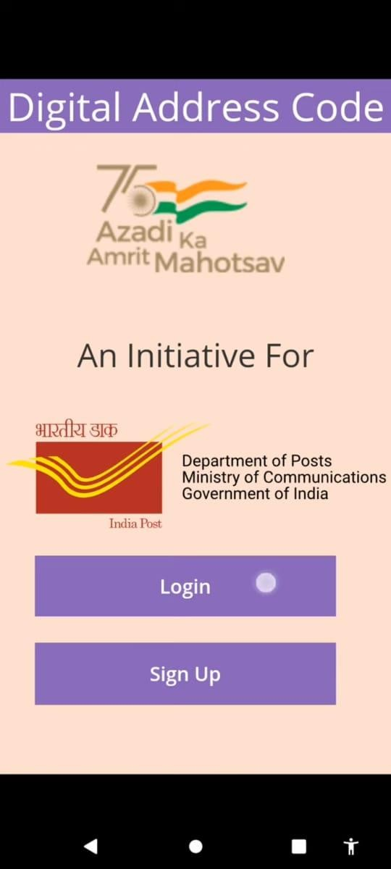

**5.1 LOGIN PAGE OF DIGITAL ADDRESS CODE**

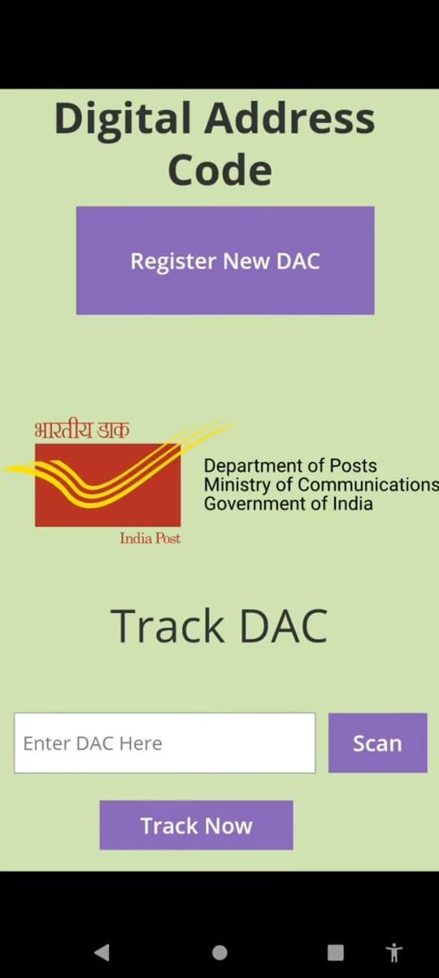

**5.2 LOGIN PAGE OF DIGITAL ADDRESS CODE**

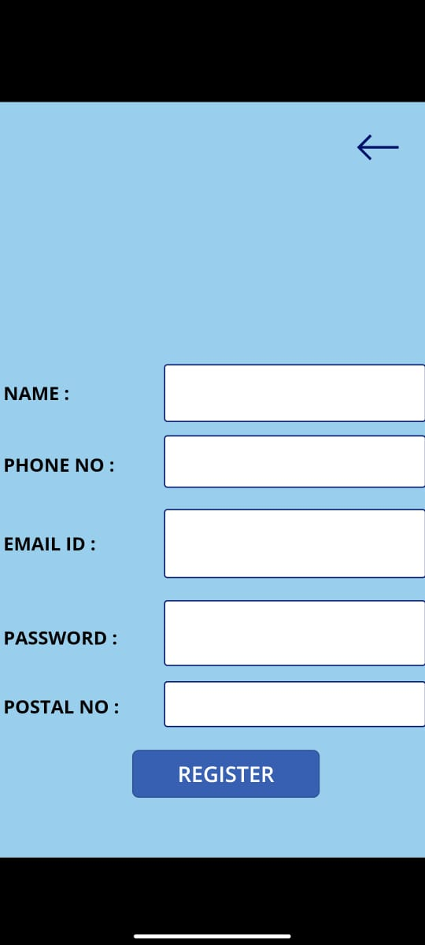

**5.3 sign in page of digital address code to create a digital address code for our location**

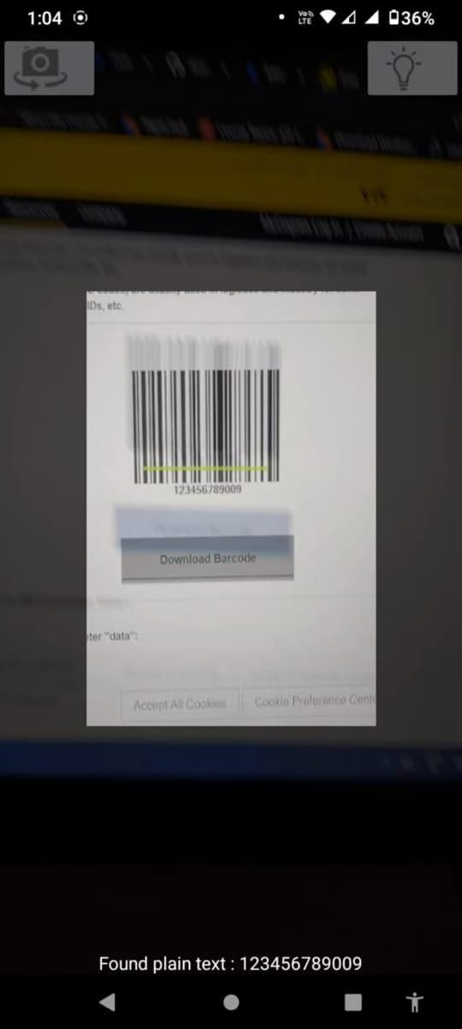**5.4 scaning of digital address code to verify the address**

**5.5 page when digital address code is invalid**

# TESTING

### TESTING

**6.1 INTRODUCTION TO TESTING**

The purpose of testing is to discover errors. Testing is the process of trying to discover every conceivable fault or weakness in a work product. It provides a way to check the functionality of components, subassemblies, assemblies and/or a finished product. It is the process of exercising software with the intent of ensuring that the Software system meets its requirements and user expectations and does not fail in an unacceptable manner. There are various types of tests. Each test type addresses a specific testing requirement.

### TYPES OF TESTING

**6.2.1 UNIT TESTING**

Unit testing involves the design of test cases that validate that the internal program logic is functioning properly, and that program inputs produce valid outputs. All decision branches and internal code flow should be validated. It is the testing of individual software units of the application .It is done after the completion of an individual unit before integration. This is a structural testing that relies on knowledge of its construction and is invasive. Unit tests perform basic tests at component level and test a specific business process, application and/or system configuration. Unit tests ensure that each unique path of a business process performs accurately to the documented specifications and contains clearly defined inputs and expected resu

### 6.2.2 INTEGRATION TESTING

Integration tests are designed to test integrated software components to determine if they actually run as one program. Integration tests demonstrate that although the components were individually satisfactory, as shown by successfully unit testing, the combination of components is correct and consistent. Integration testing is specifically aimed at exposing the problems that arise from the combination of components.

### 6.2.3 FUNCTIONAL TESTING

Functional tests provide systematic demonstrations that functions tested are available as specified by the business and technical requirements, system documentation, and user manuals.

Functional testing is centered on the following items:

Valid Input : identified classes of valid input must be accepted.

Invalid Input

: identified classes of invalid input must be rejected.

Functions : identified functions must be exercised.

Output : identified classes of application outputs must be exercised.

Systems/Procedures: interfacing systems or procedures must be invoked. Organization and preparation of functional tests is focused on requirements, key functions, o

### TEST CASES

* + 1. **CLASSIFICATION**

|  |  |  |  |  |  |
| --- | --- | --- | --- | --- | --- |
| Test  caseID | Test case  name | Purpose | Input | Output | conclusion |
| 1 | Dac identification | To detect Dac number | The user givesthe input in the form of a  digital code | An output is digital address code is  verified | Digital address code is verified |
| 2 | Running of digital address code | To run digital address code. | The user gives the input in the form of a digital code | An output is map is opened for the given digital  code | Digital address code is running |

# 7.CONCLUSION

### CONCLUSION & FUTURE SCOPE

* 1. **PROJECT CONCLUSION**

After the implement of this project we can easily trace the addresses of the required persons and it is a time saving process and we can improve last mile delivery efficiency for e-commerce , eliminate frauds in relation to fake addresses.

### FUTURE SCOPE

We can add this digital address code with our adhar card from which can easily update our address in our adhar as welland we can easily eliminatae the fraud or fake address as our digital address code is directly connected with adhar card

1. **BIBLIOGRAPHY**

##### 8. BIBLIOGRAPHY

* 1. **REFERENCES**

1. S. G. Bhele and V. H. Mankar, “A Review Paper on Face Recognition Techniques,” Int. J. Adv. Res. Comput. Eng. Technol., vol. 1, no. 8, pp. 2278–1323, 2012.
2. V. Bruce and A. Young, “Understanding face recognition,” Br. J. Psychol., vol. 77, no. 3, pp. 305–327, 1986.
3. D. N. Parmar and B. B. Mehta, “Face Recognition Methods & Applications,” Int.

J. Comput. Technol. Appl., vol. 4, no. 1, pp. 84–86, 2013.

1. K. Delac, Recent Advances in Face Recognition. 2008.

##### GITHUB LINK

<https://github.com/sravya666/Face-recognition-audio-output/tree/master>

CMRTC 23